|  |  |
| --- | --- |
| **Ex. No 1.a** | **Use different selection and transform tool to modify or improve the image.** |
| **Date:** |

**Aim:**

To use different selection and transform tool to modify or improve the image using InkScape Software.

**Procedure:**

1. Go to the browser and paste the link <https://inkscape.org/release/inkscape-1.3/>
2. Download the Inkscape software based on your OS.
3. Don’t use app image if you are using Linux or Debian based OS, use app instead.
4. Once you install the software, it shows the below image as a welcome screen.

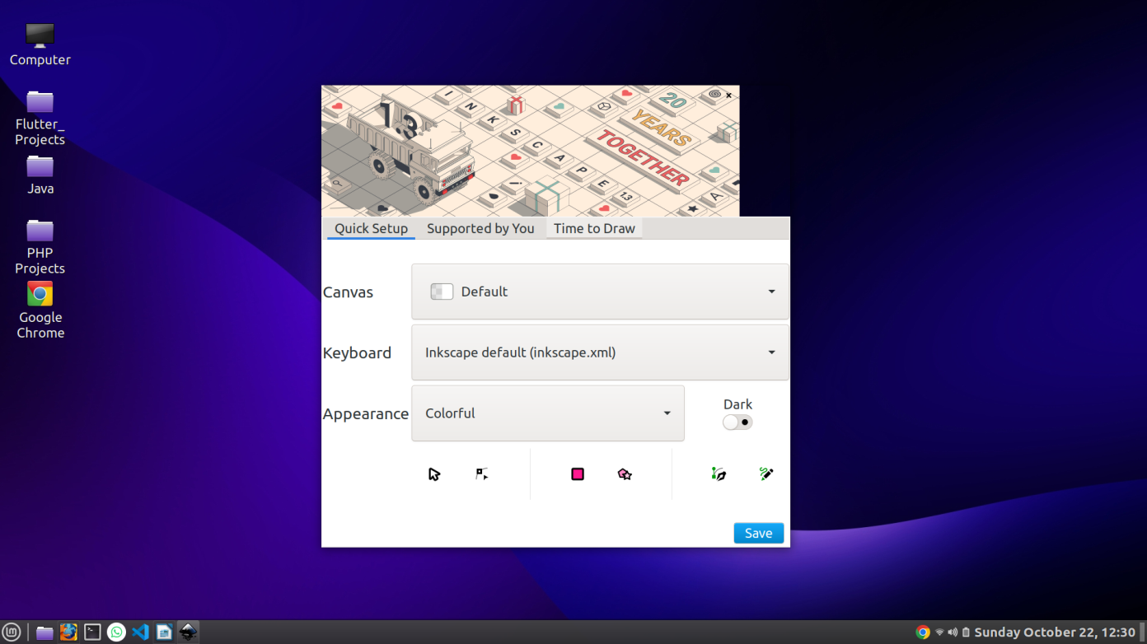

**Working with InkScape:**

**Step 1:** Click on the Time to Draw Option on the Welcome Screen.

**Step 2:** Click on the New Document, once you done it shows like this.

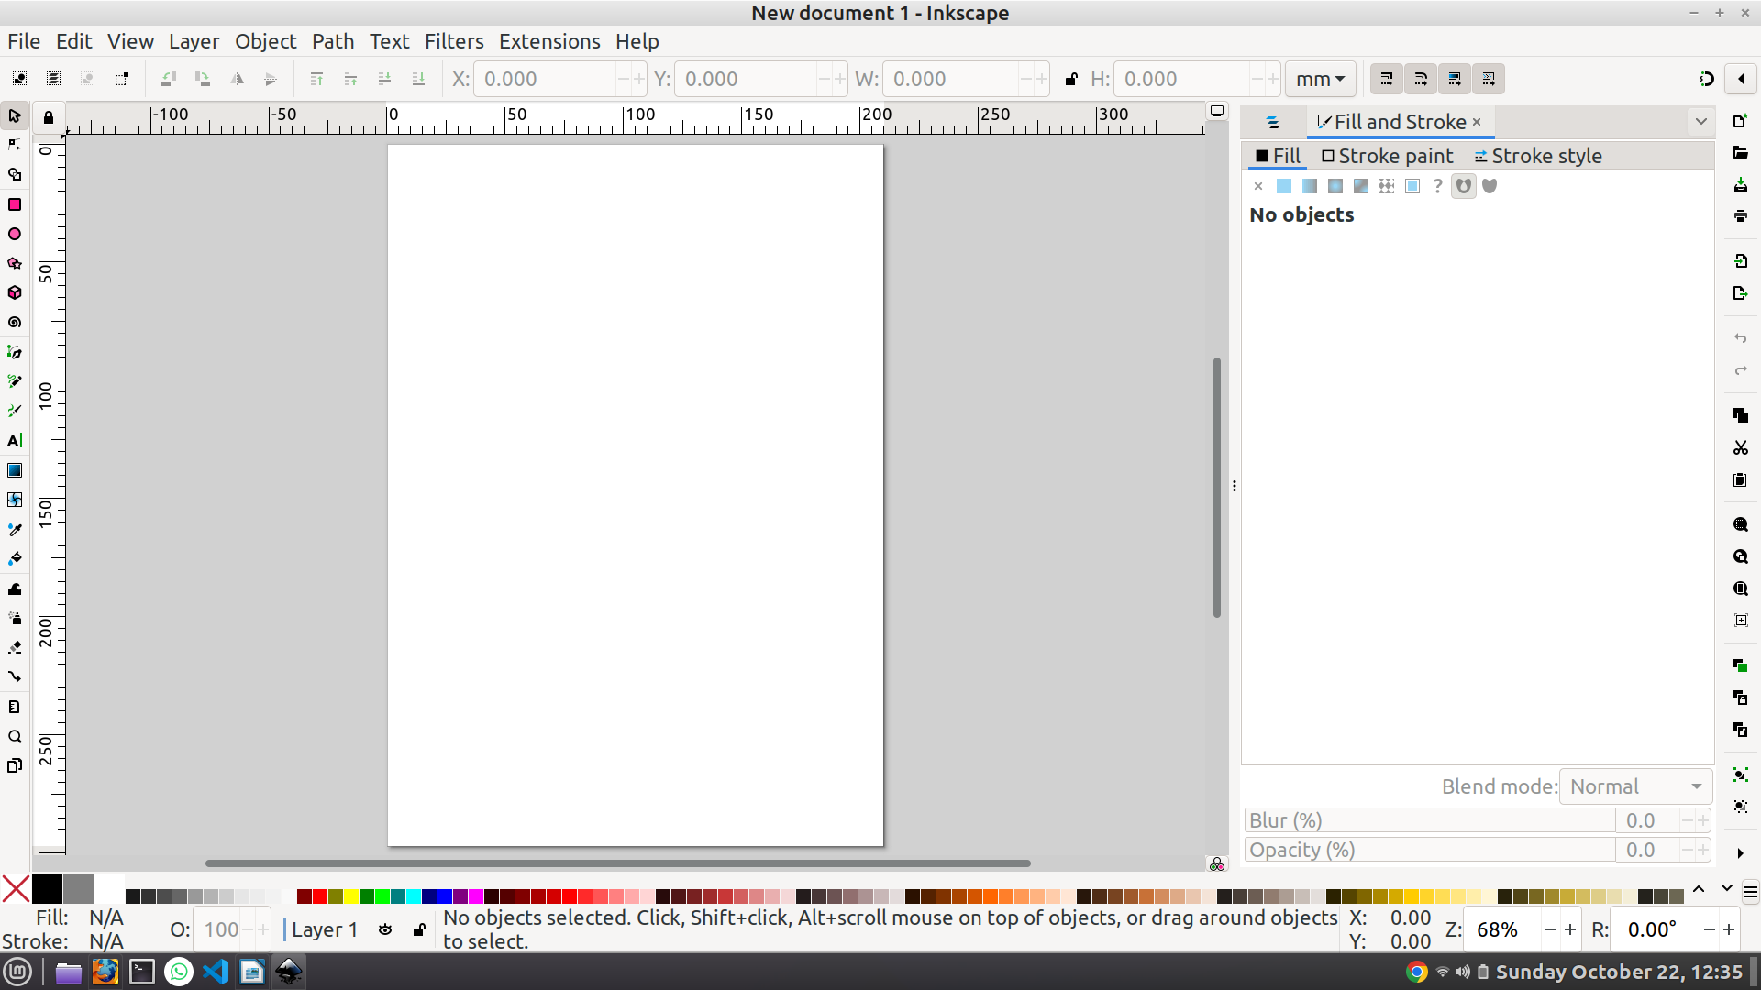

**Step 3:** Download any image of your choice from the internet

**Step 4:** Import the image using File menu in the navigation or click on the icon as shown below

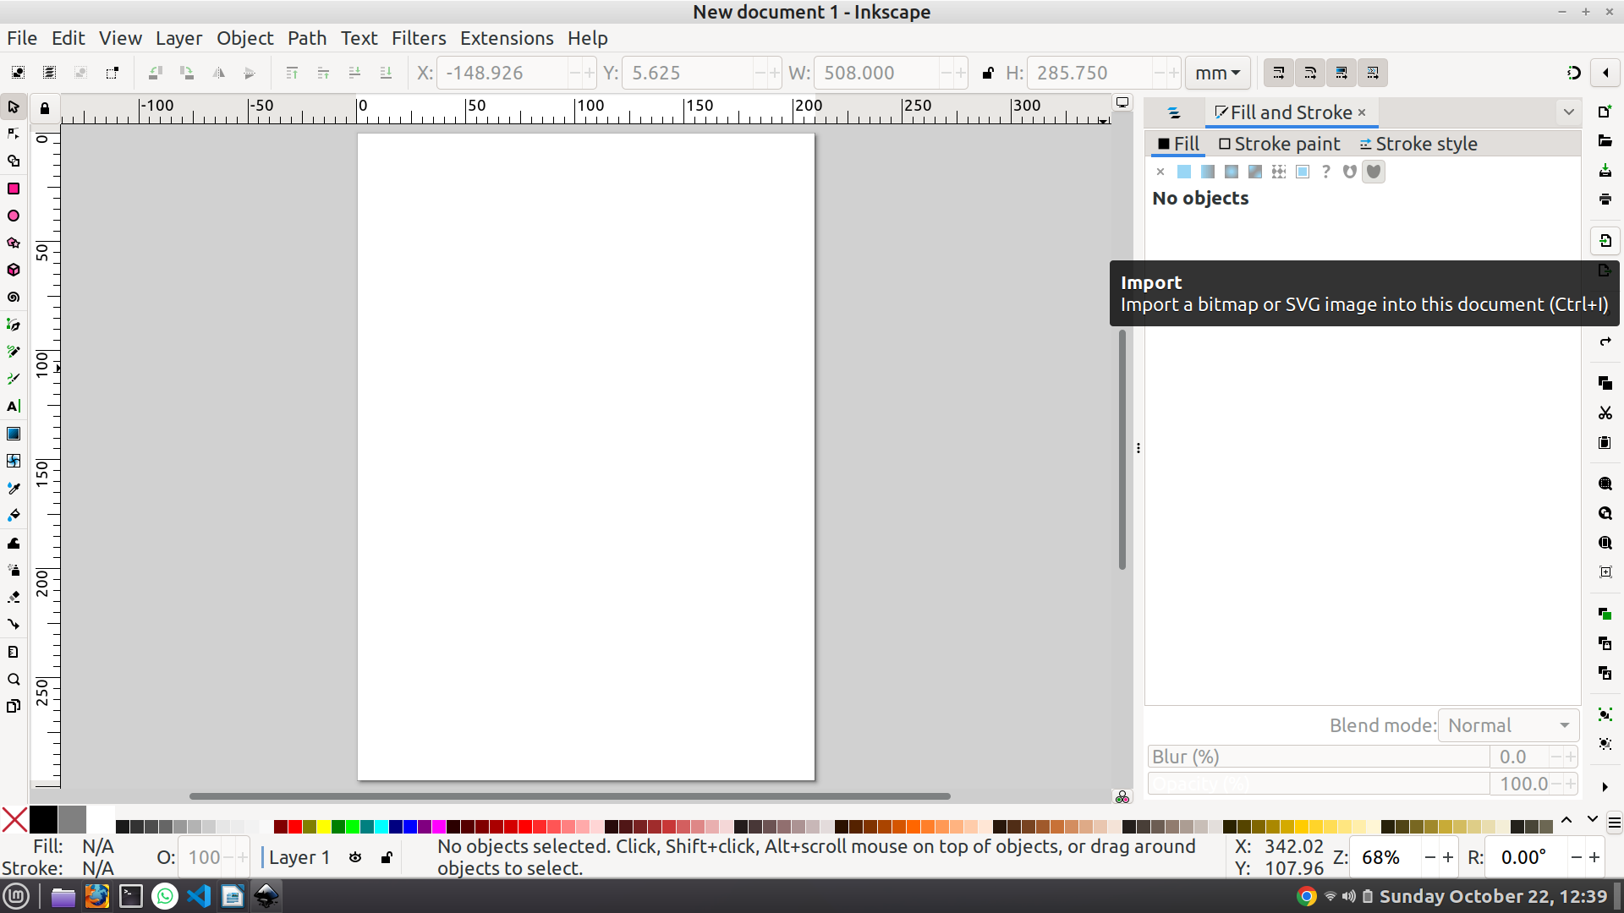

**Step 5:** After importing the screen looks like this

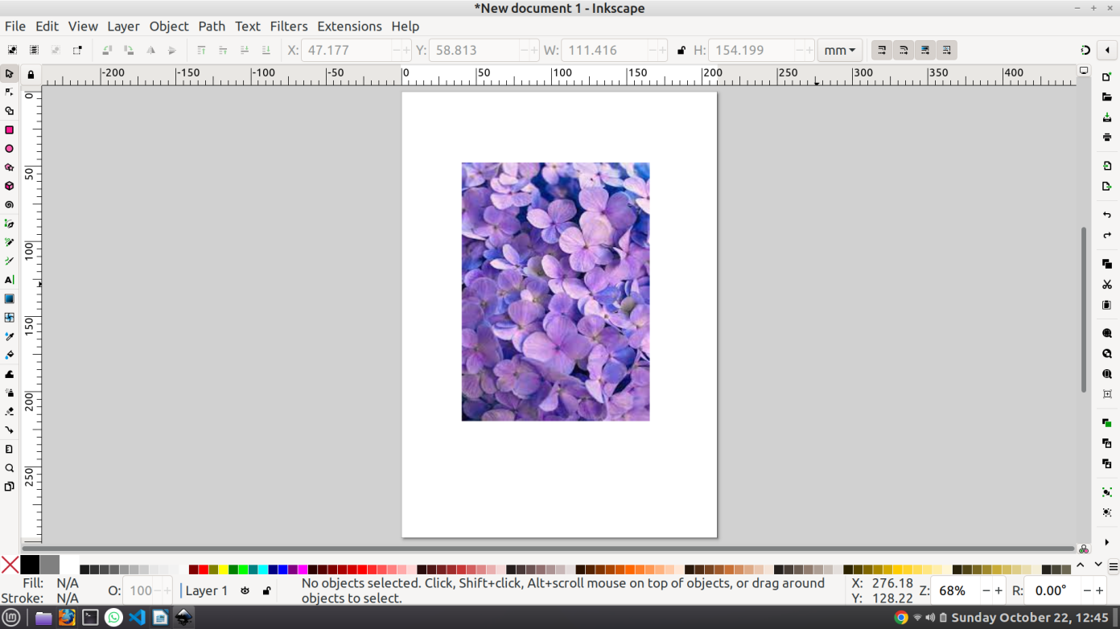

**Step 6:** Click R to use the rectangle tool and make a frame as in the image.

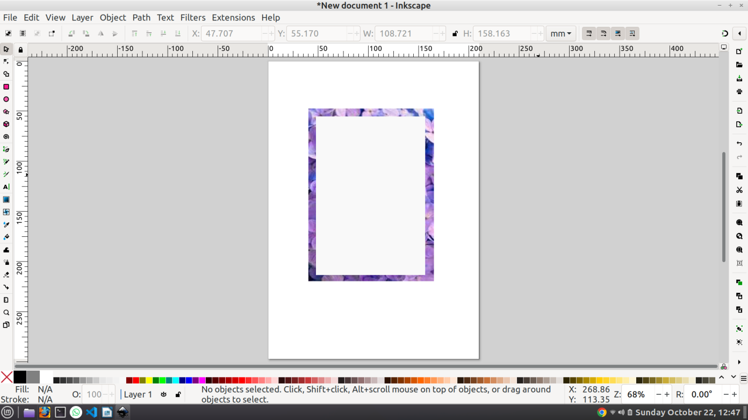

**Step 7:** Hold Shift button and select the image and the rectangle then press ctrl+G to group the both layers.

**Step 8:** Adjust the grouped layer to the full frame as shown in the image

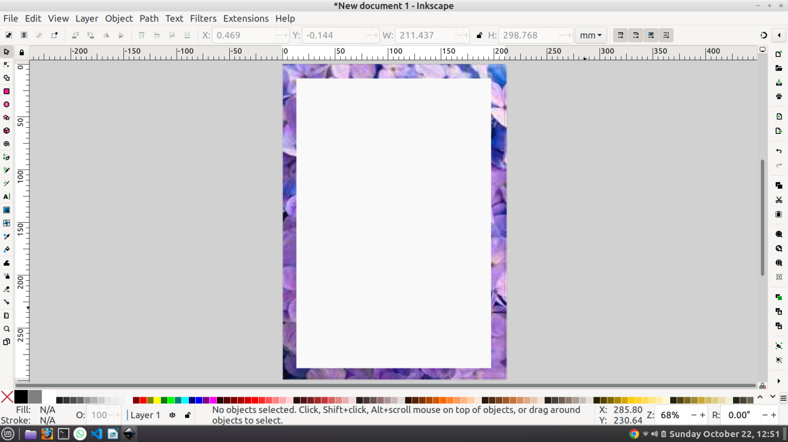

**Step 9:** Now we are able to use selection and transform tool to make changes in the image.

**Result:**

Thus, the expected output using InkScape software was achieved successfully.

|  |  |
| --- | --- |
| **Ex. No 1.b** | **Create logos and banners for home pages of websites** |
| **Date:** |

**Aim:**

To Create Logos and banners for home pages of websites using InkScape Software.

**Procedure:**

1. Go to the browser and paste the link <https://inkscape.org/release/inkscape-1.3/>
2. Download the Inkscape software based on your OS.
3. Don’t use app image if you are using Linux or Debian based OS, use app instead.
4. Once you install the software, it shows the below image as a welcome screen.



**Working with InkScape:**

**Step 1:** Click on the Time to Draw Option on the Welcome Screen.

**Step 2:** Click on the New Document, once you done it shows like this.



**Step 3:** Press on the Ctrl+Alt+N, then click on the screen and choose your desktop resolution as shown in the picture.

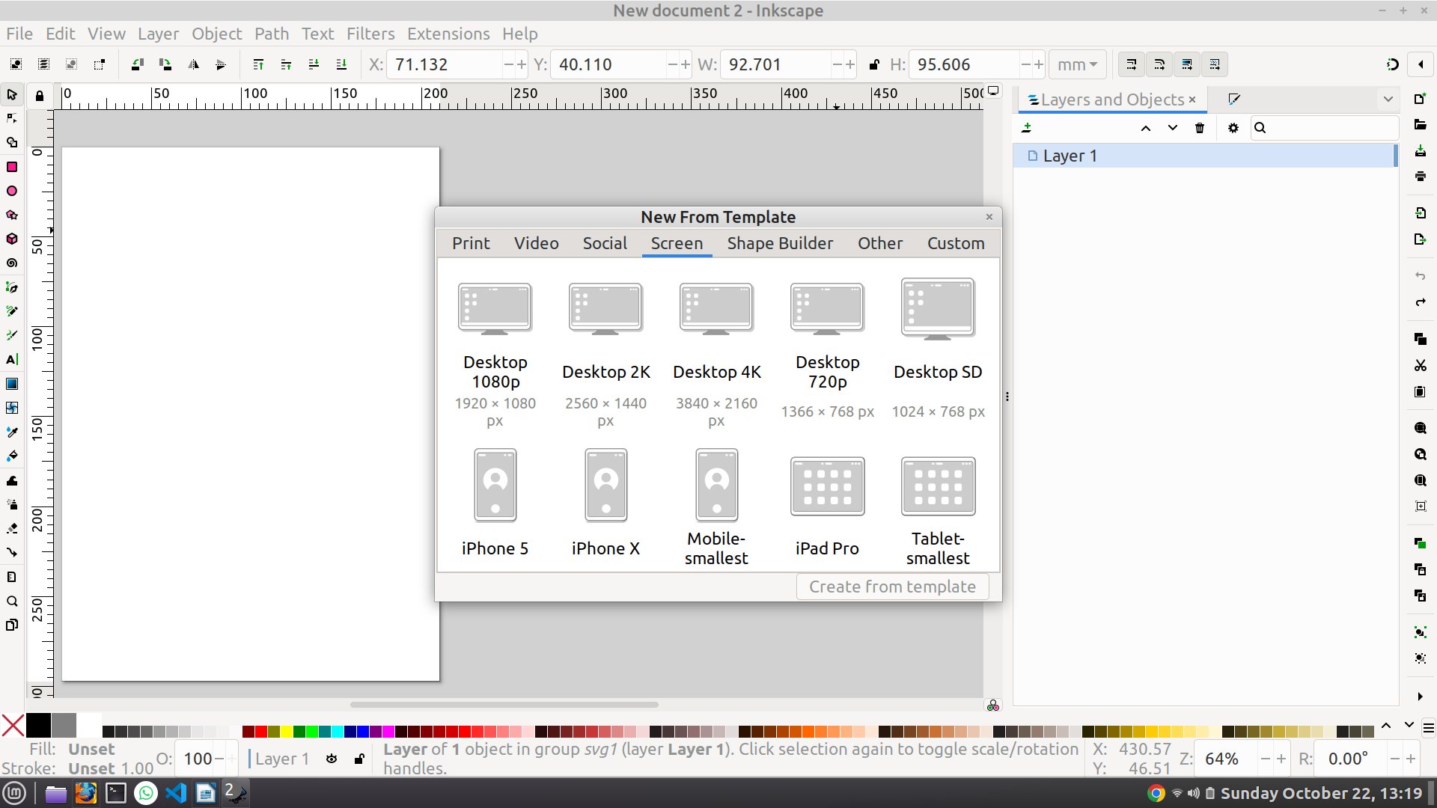

**Step 4:** Click on the R button and place the rectangle on the top of the screen as shown below

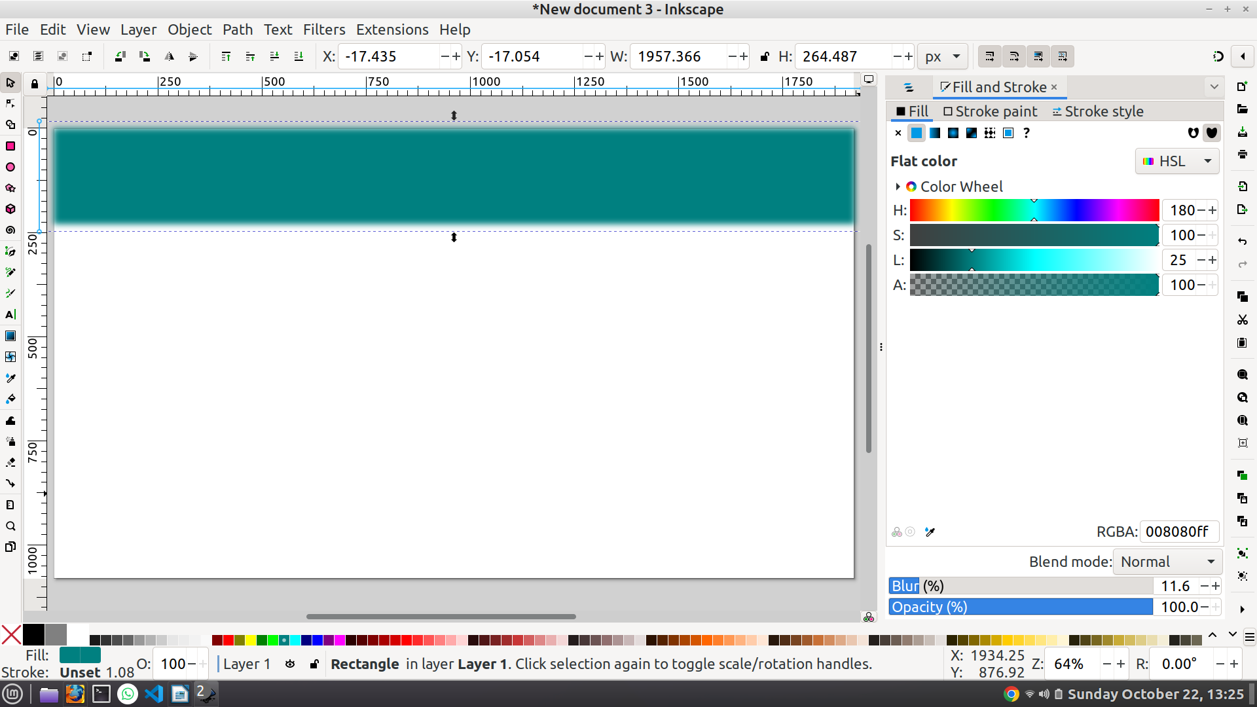

**Step 5:** Press T to add the Text button and edit the text as shown below

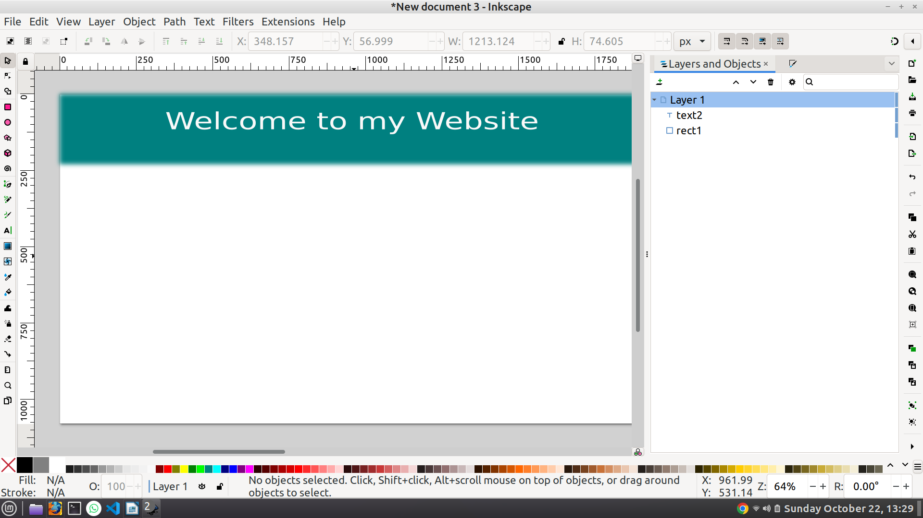

**Step 6:** Add Home, About Us and Contact text in the Banner as shown below

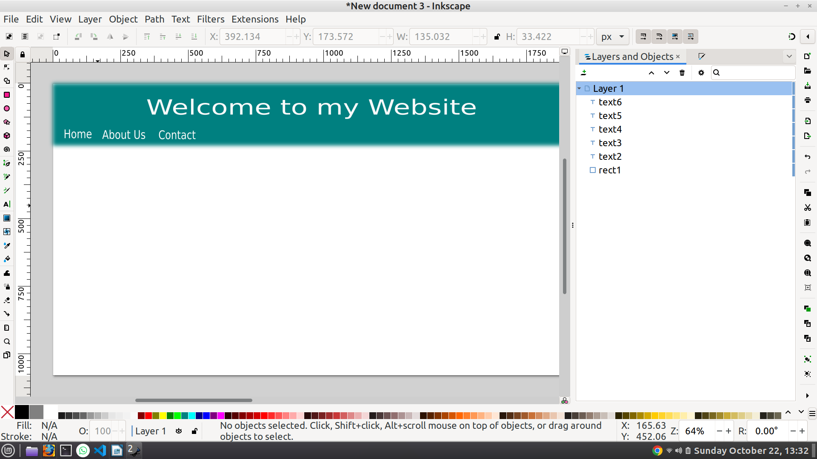

**Result:**

Thus, the expected output using InkScape software was achieved successfully.

|  |  |
| --- | --- |
| **Ex. No 2.a** | **Working with Audio Editing tool Audacity for Sound Mixing and special effects like fade in or fade out** |
| **Date:** |

**Aim:**

To create sound mixing and special effects like fade in or fade out using Audacity Software.

**Procedure:**

1. Go to the browser and paste the link <https://www.audacityteam.org/>
2. Install the Software based on your OS.
3. Once you have done it, the welcome screen looks like this.

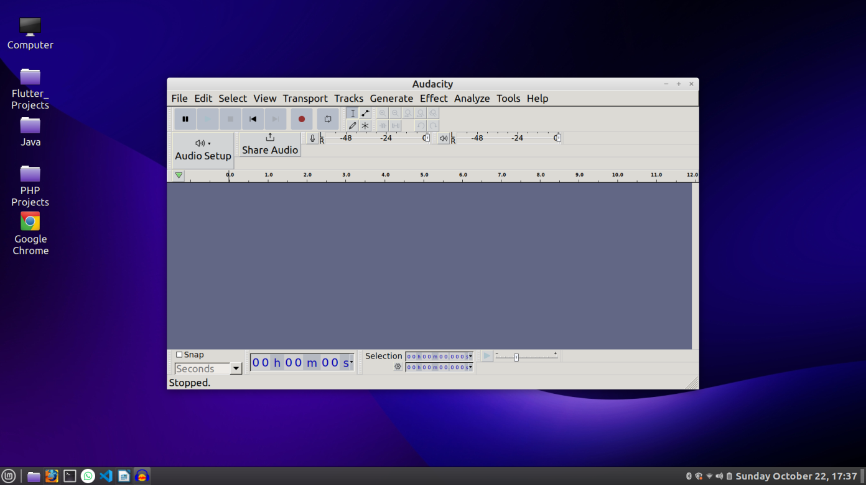

**Working with Audacity Software:**

**Step 1:** Click on the File menu and Import the audio file then the screen looks like this

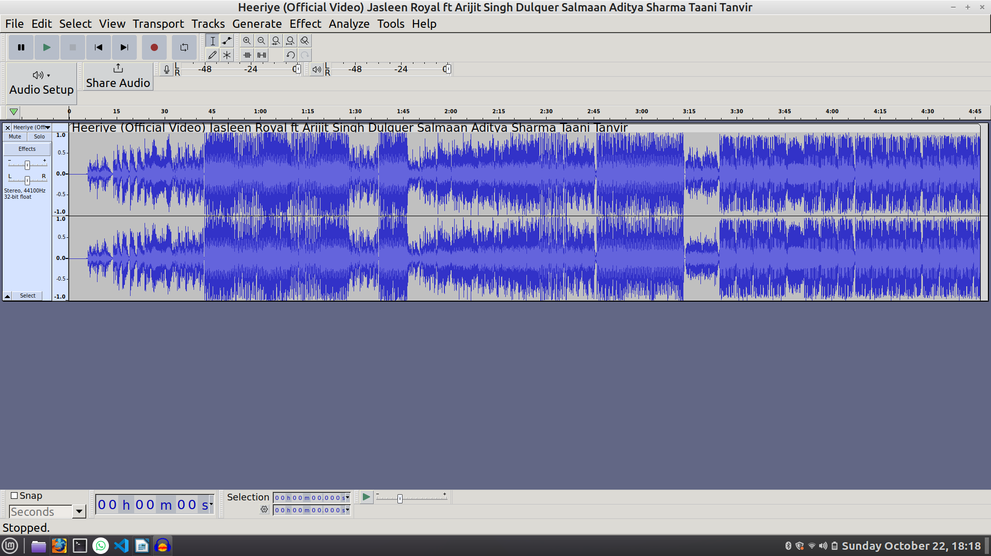

**Step 2:** Select the Starting and end point as shown in the image

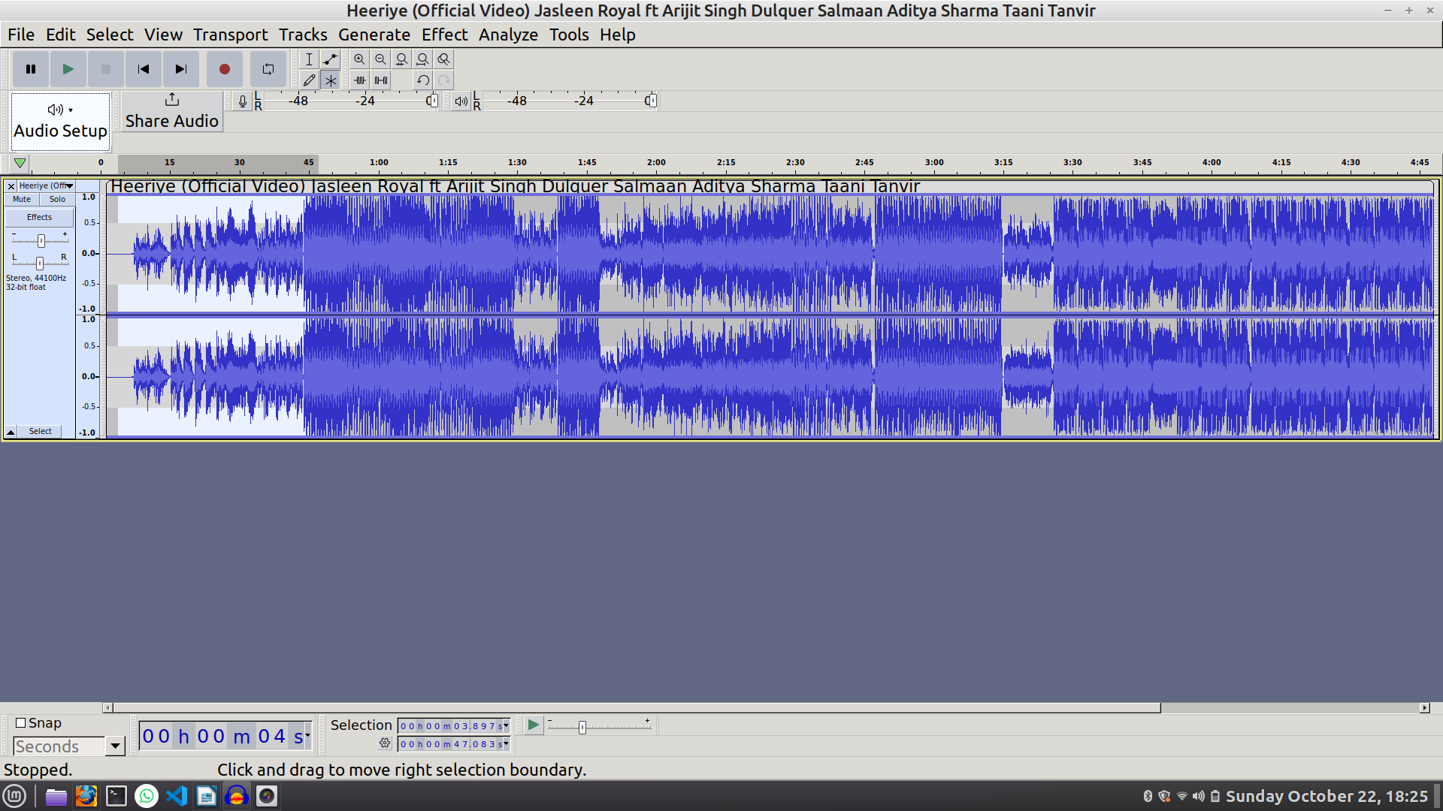

**Step 3:** Click on the Effect option in the navigation bar.

**Step 4:** Click on the Fadding.

**Step 5:** Click on the Fade in option for the starting region and Fade out option for the ending region.

**Result:**

Thus, the expected fade in and fade out sound mixing using Audacity software was achieved successfully.

|  |  |
| --- | --- |
| **Ex. No 2.b** | **Working with Audio Editing tool Audacity to perform audio compression by choosing a proper codec** |
| **Date:** |

**Aim:**

To perform audio compression by choosing a proper codec using Audacity Software.

**Procedure:**

1. Go to the browser and paste the link <https://www.audacityteam.org/>
2. Install the Software based on your OS.
3. Once you have done it, the welcome screen looks like this.



**Working with Audacity Software:**

**Step 1:** Click on the File menu and Import the audio file then the screen looks like this



**Step 2:** Click on the effect in the Navigation Bar and click on the volume and compression then adjust the volume as shown in the image.

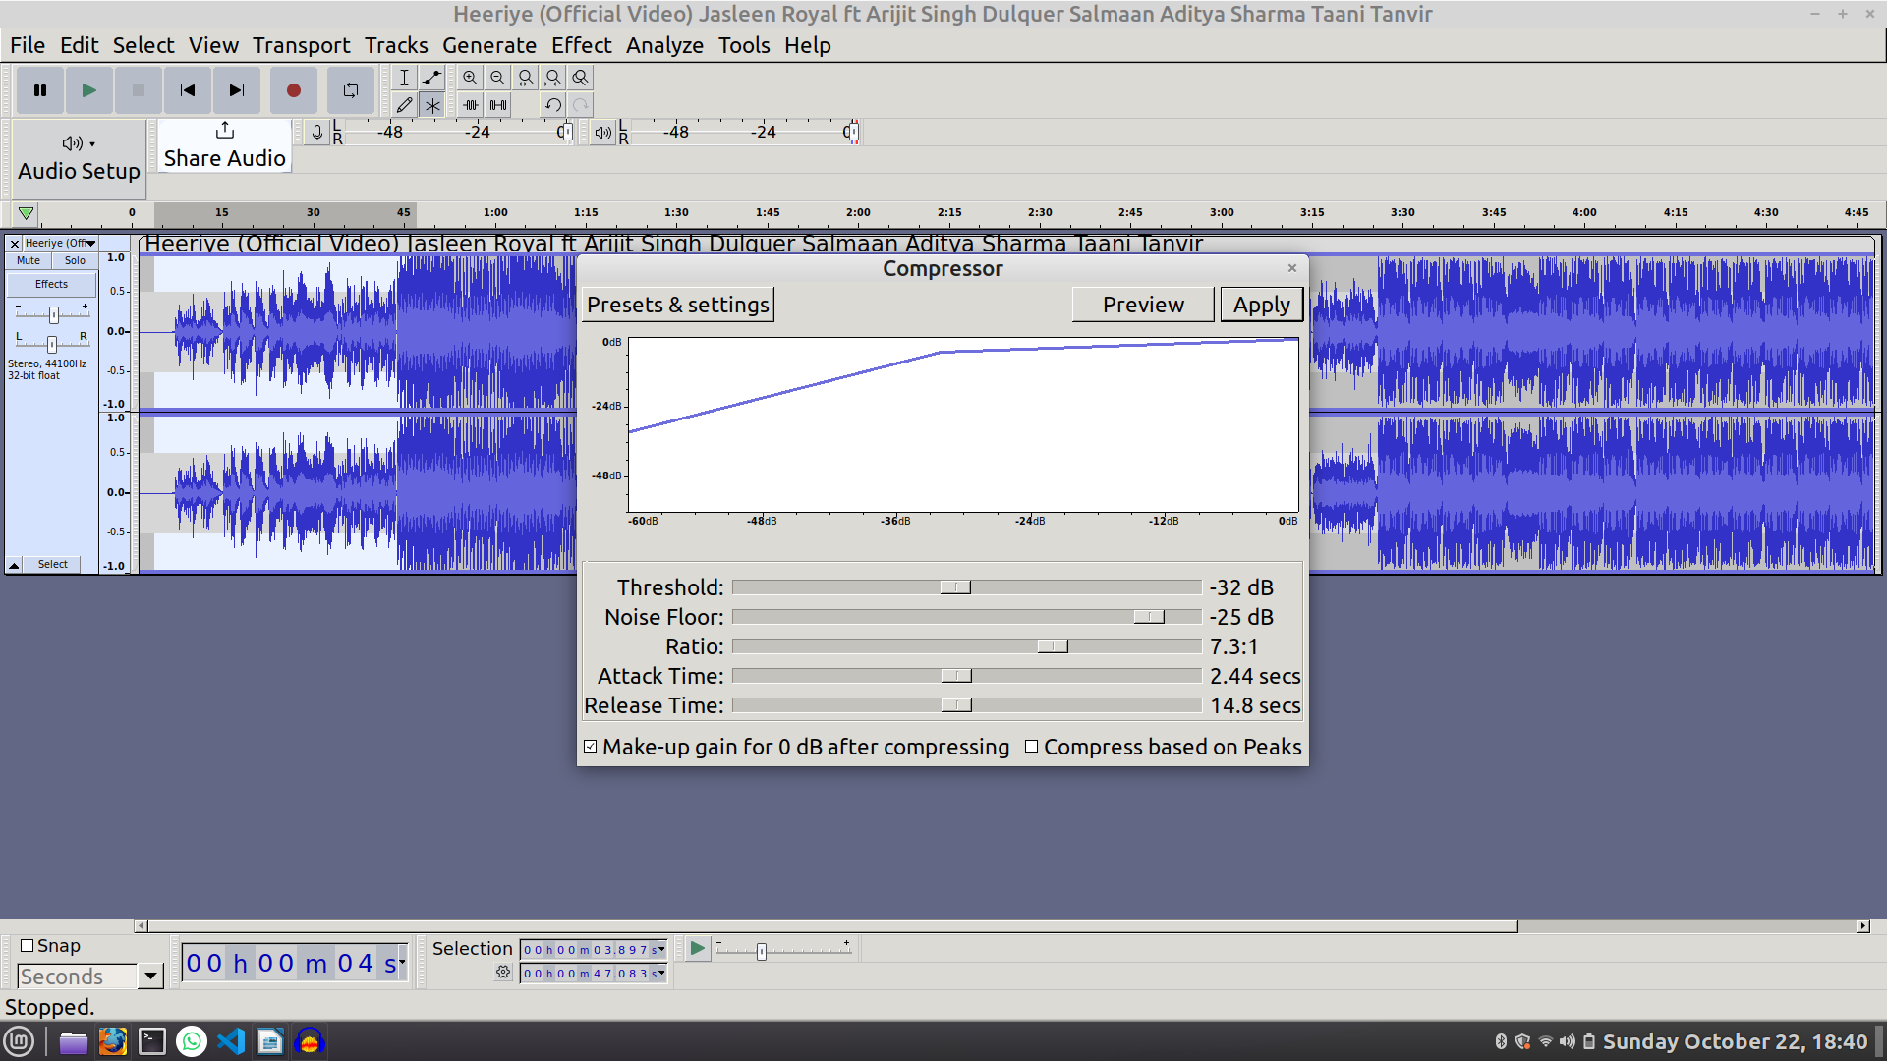

**Step 3:** Once done, click on the preview and play the audio then click on the apply button to finalize the compressed volume of the audio.

**Result:**

Thus, the expected audio compressing using Audacity software was achieved successfully.

|  |  |
| --- | --- |
| **Ex. No 3.a** | **Working with Video Editing tool Open Shot to edit and mix video content, remove noise, create special effects, add captions** |
| **Date:** |

**Aim:**

To edit and mix video content, remove noise, create special effects and to add captions using Openshot software.

**Procedure:**

1. Go to the browser and paste the link <https://www.openshot.org/>
2. Install the software based on your OS.
3. Once done, the welcome screen looks like this

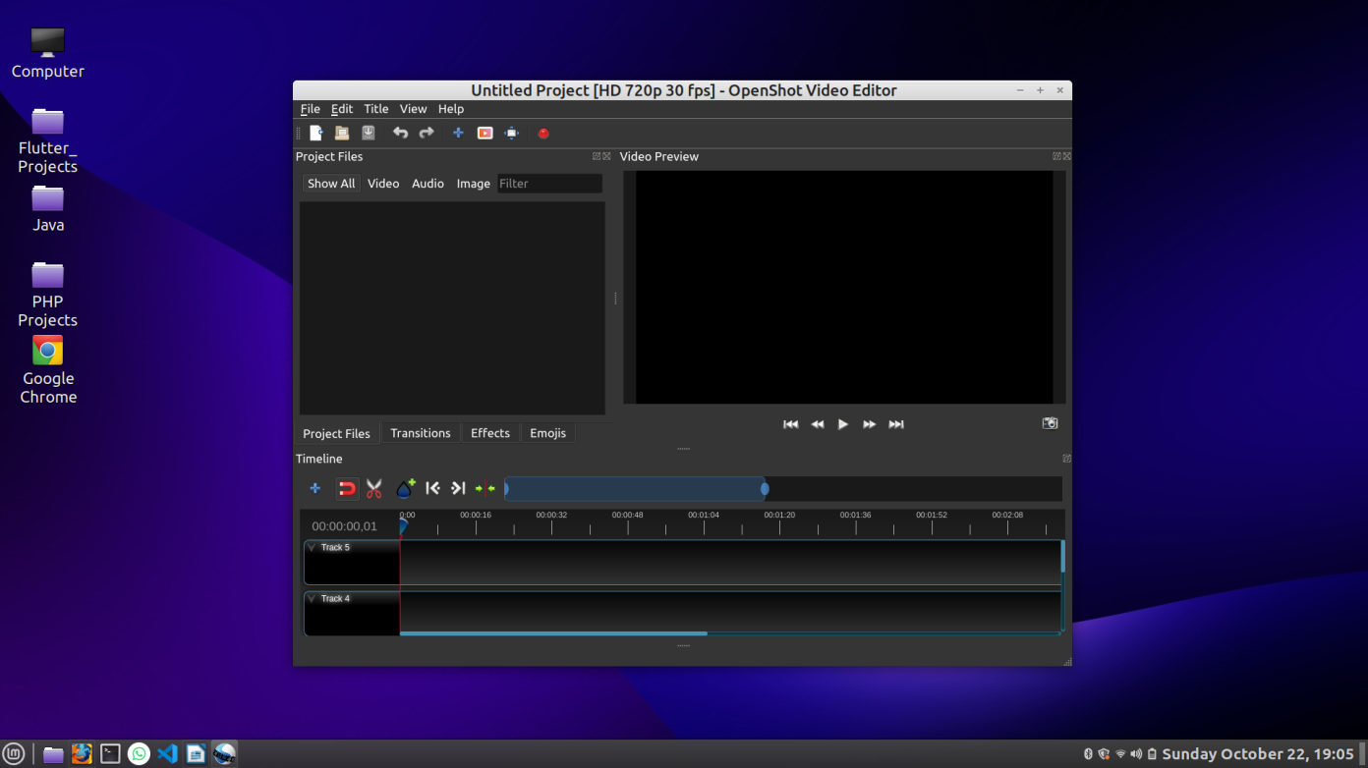

**Working with Open shot Software:**

**Step 1:** Click on the File menu in the navigation bar and then import required files for editing.

**Step 2:** Drag and Drop the video to the track then the screen looks like this

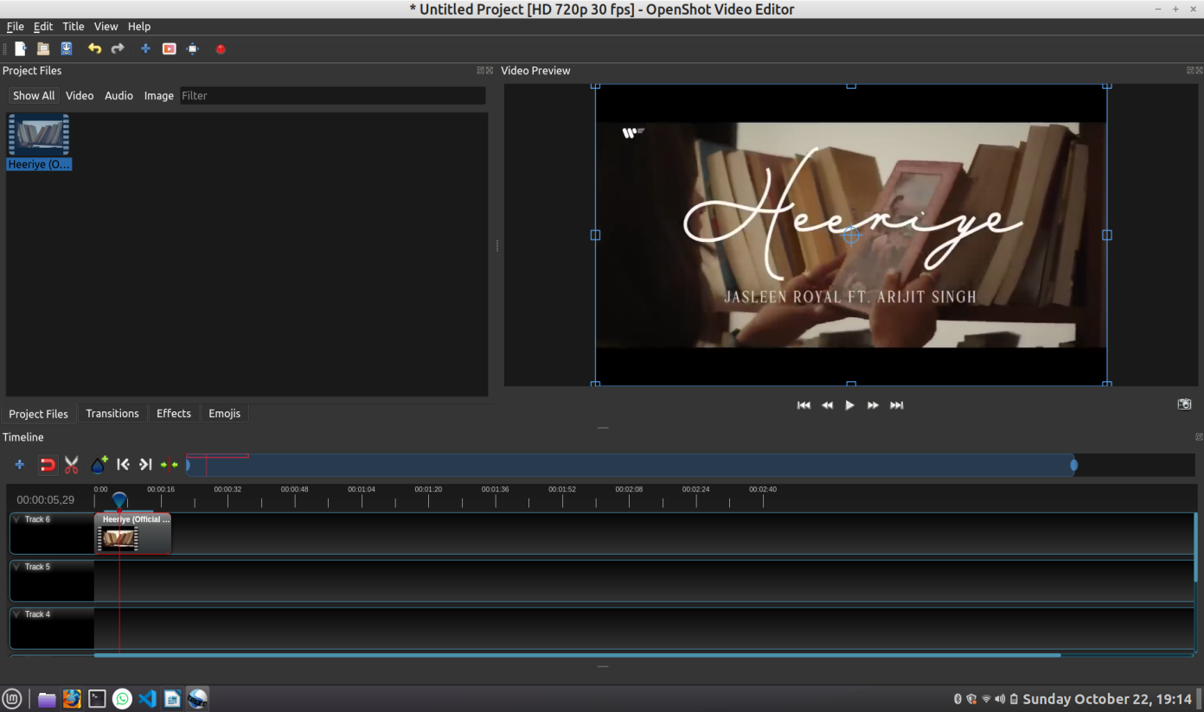

**Step 3:** Right click on the Video, then click on the slice option and click on the keep both sides

**Step 4:** Click on the first part of the video then click on the Transitions which was in the upper side of the track.

**Step 5:** Drag and drop the transition effect between the sliced video part, and the screen looks like this.

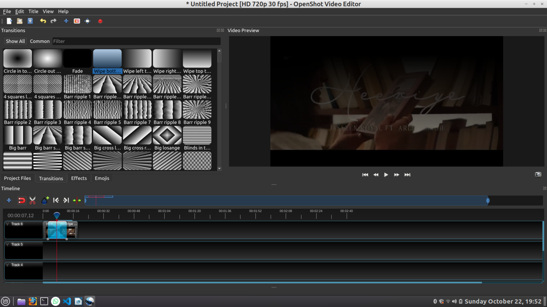

**Step 6:** Explore Effects and Other options in the app

**Result:**

Thus, the expected output after adding transitions and simple effects using Open shot software was achieved successfully.

|  |  |
| --- | --- |
| **Ex. No 3.b** | **Working with Video Editing tool Open Shot to Compress and convert video file format to other popular formats.** |
| **Date:** |

**Aim:**

To compress and convert video file format to other popular formats using Open shot software.

**Procedure:**

1. Go to the browser and paste the link <https://www.openshot.org/>
2. Install the software based on your OS.
3. Once done, the welcome screen looks like this



**Working with Openshot Software:**

**Step 1:** Click on the File menu in the navigation bar and then import required files for editing.

**Step 2:** Drag and Drop the video to the track then the screen looks like this

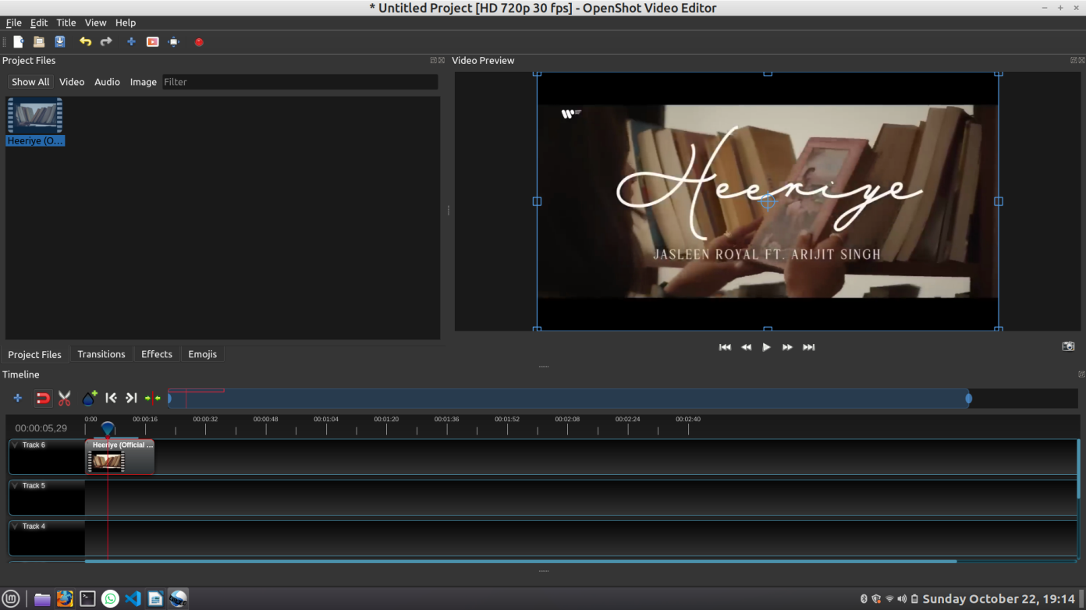

**Step 3:** Press ctrl+E then the screen looks like this

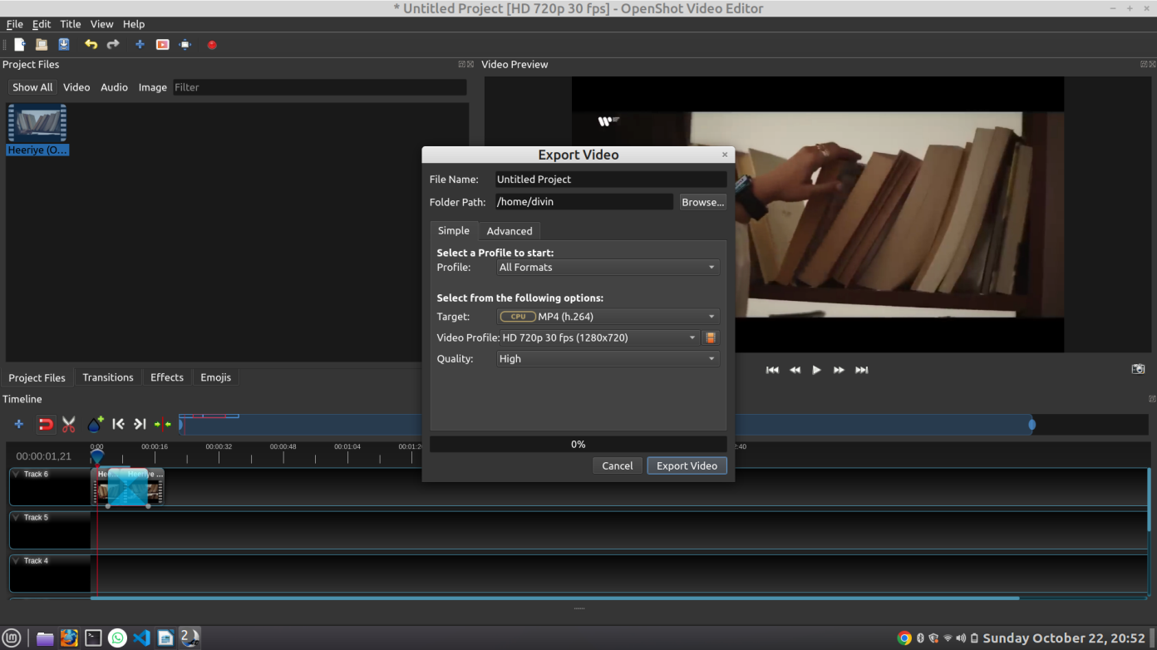

**Step 4:** Click on the target then choose any of the other format except mp4.

**Step 5:** Click on the Video Profile and choose your resolution.

**Step 6:** Click on the quality and then choose the quality of the video.

**Step 7:** Once finished all the settings, click on the export video button, then the screen looks like this

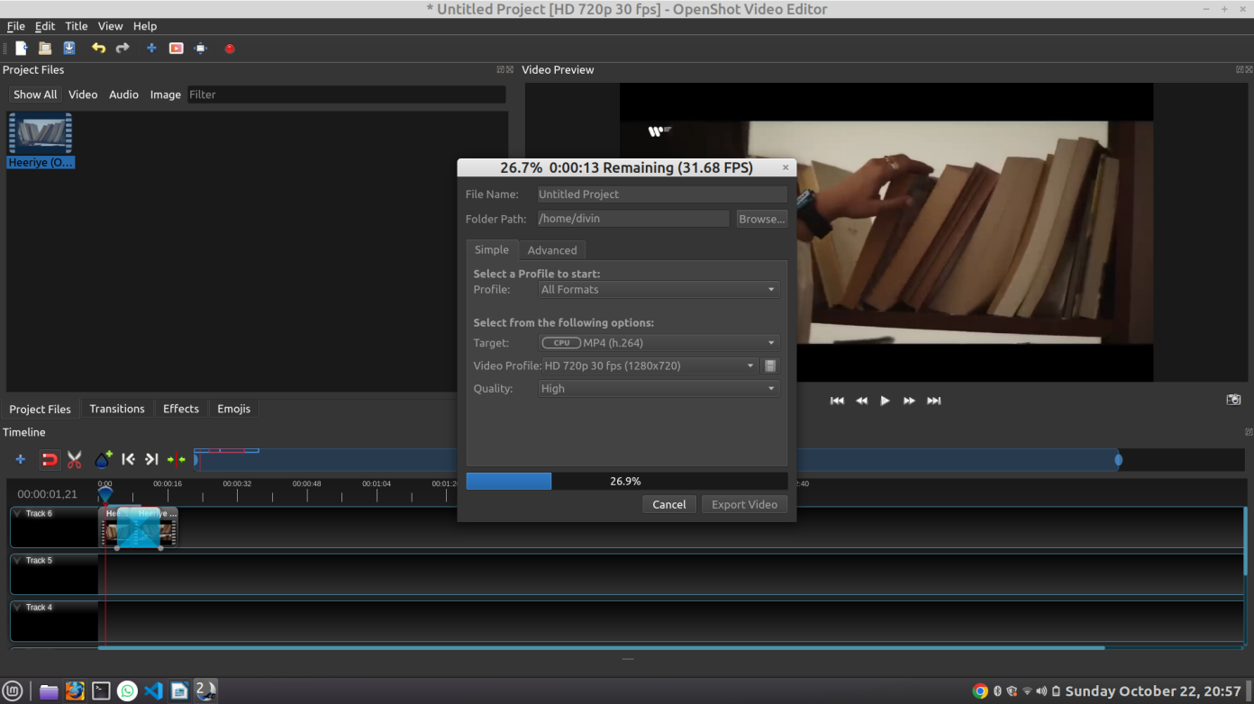

**Result:**

Thus, the expected output after converting the video to various formats using Open shot software was achieved successfully.

|  |  |
| --- | --- |
| **Ex. No 4.a** | **Working with Web and Mobile Authoring tool Word press to Design simple homepage with banners, logos, tables and quick links.** |
| **Date:** |

**Aim:**

To design simple homepage with banners, logos, tables and quick links using Word press.

**Working with Word press Online:**

1. Go to the browser and paste the link <https://wordpress.com/>
2. Click on the get started and create a account.
3. Choose free plan as shown in the picture.

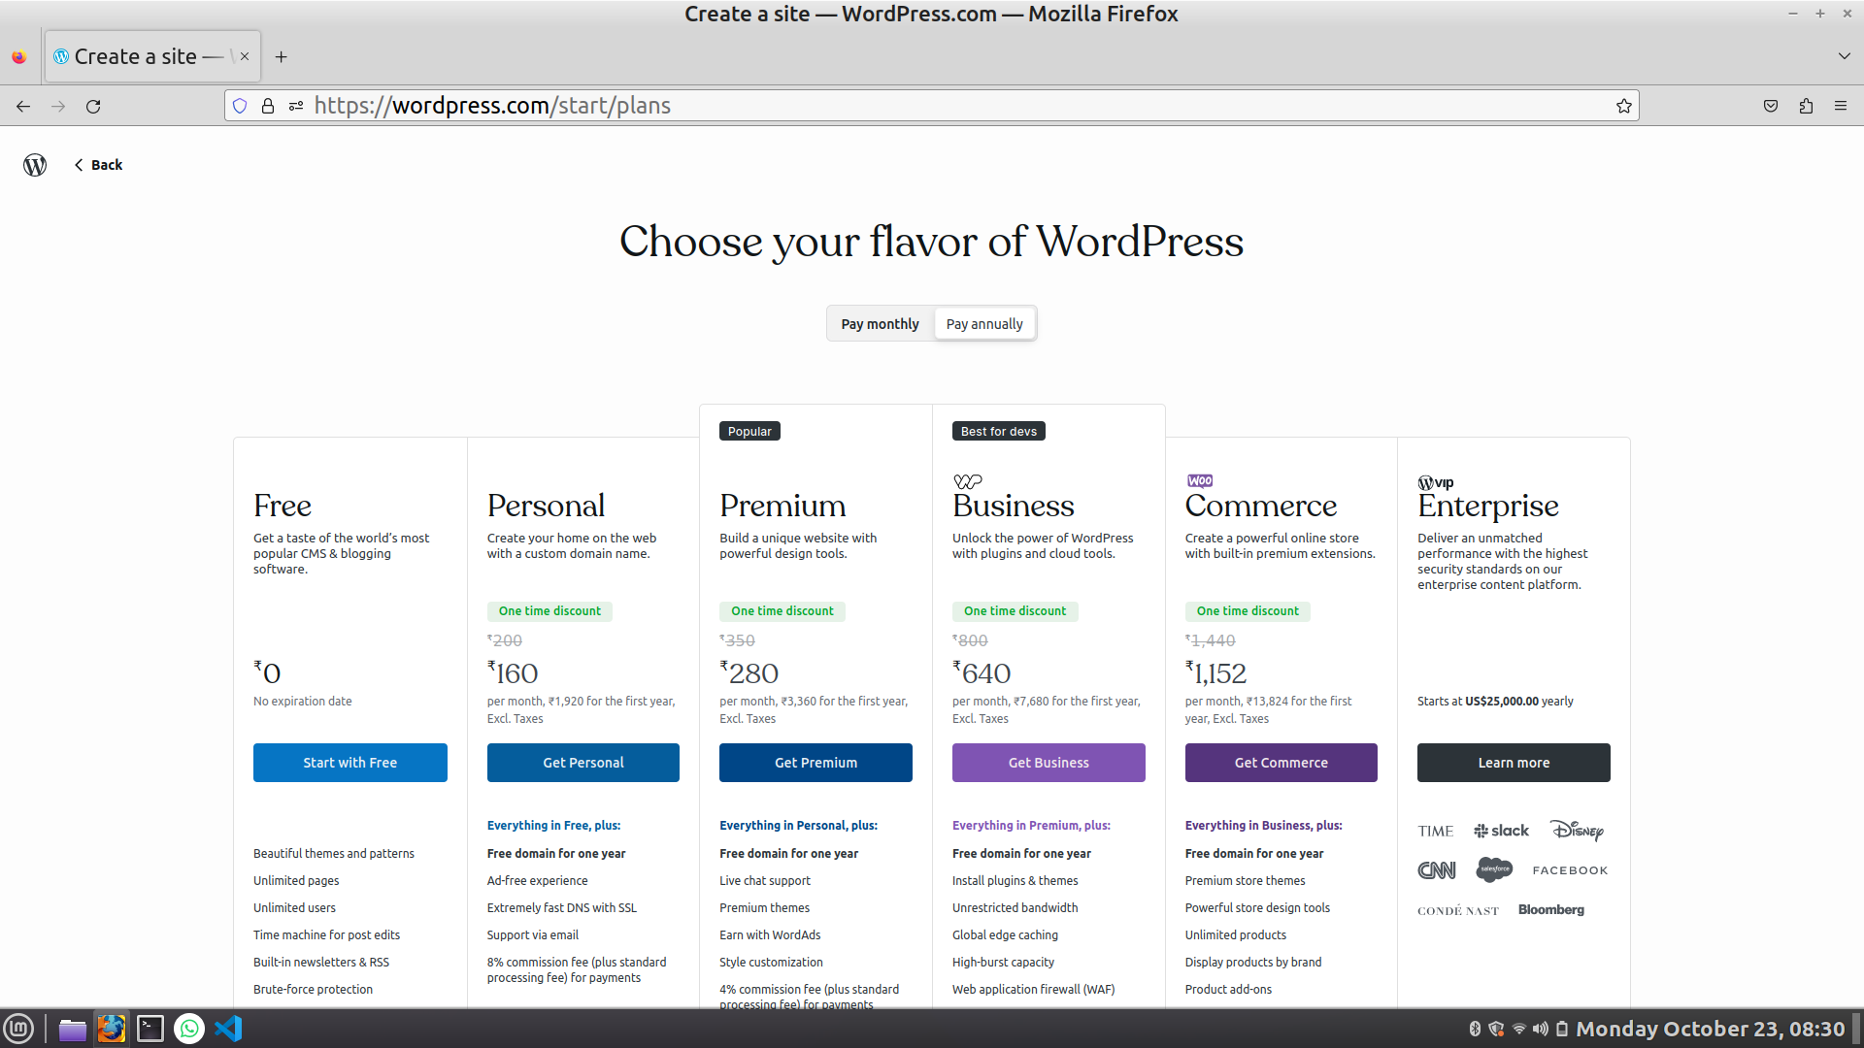

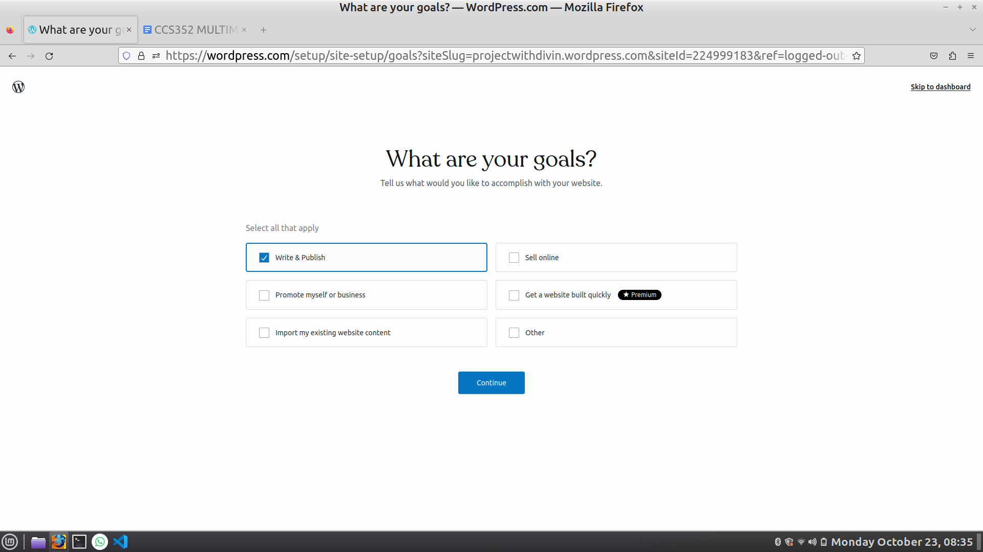

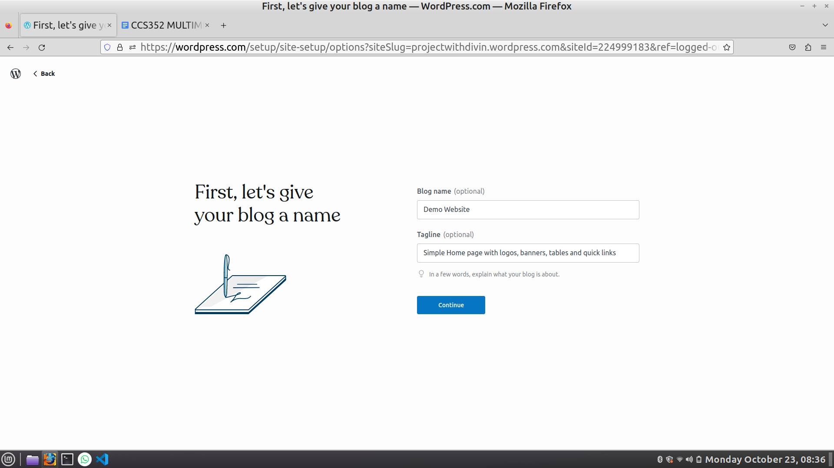

1. Click on the third option choose a design as shown in the image.

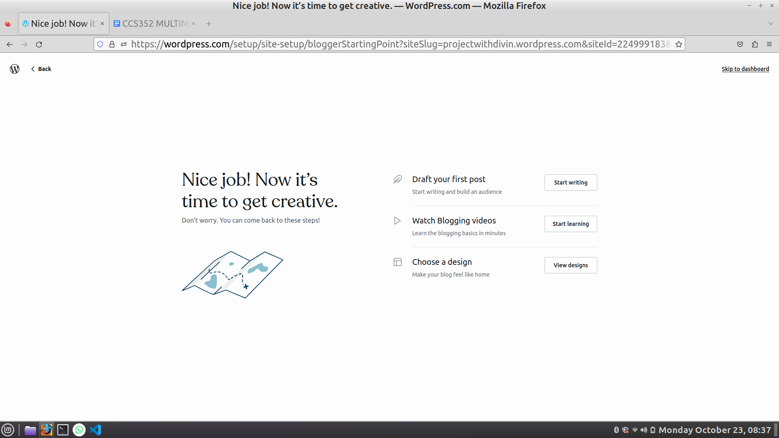

1. Choose any of the design as shown in the image and start editing.

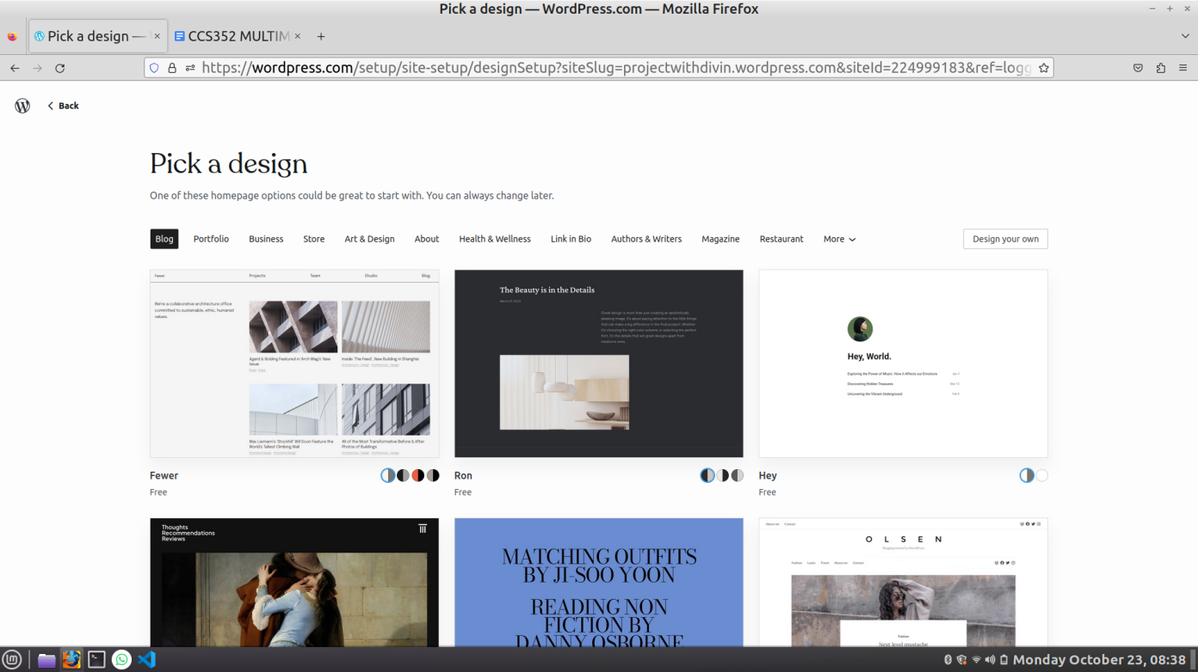

1. Once done, your site looks similar to the image as shown.

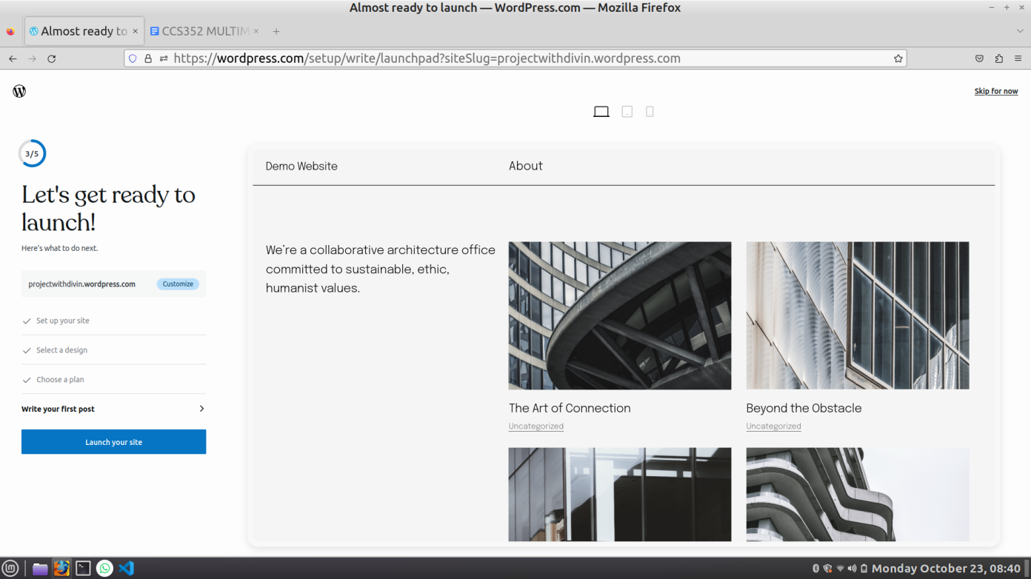

**Result:**

Thus, the expected design using word press was achieved successfully.

|  |  |
| --- | --- |
| **Ex. No 4.b** | **Working with Web and Mobile Authoring tool Wordpress to Provide a search interface and simple navigation from the home pages of the websites.** |
| **Date:** |

**Aim:**

To provide a search interface and simple navigation from the home pages of the websites using Wordpress.

**Working with Wordpress Online:**

1. Go to the browser and paste the link <https://wordpress.com/>
2. Click on the get started and create a account.
3. Choose free plan as shown in the picture.







1. Click on the third option choose a design as shown in the image.



1. Choose any of the design which has a search bar as shown in the image and start editing.



1. Once done, your site looks similar to the image as shown.

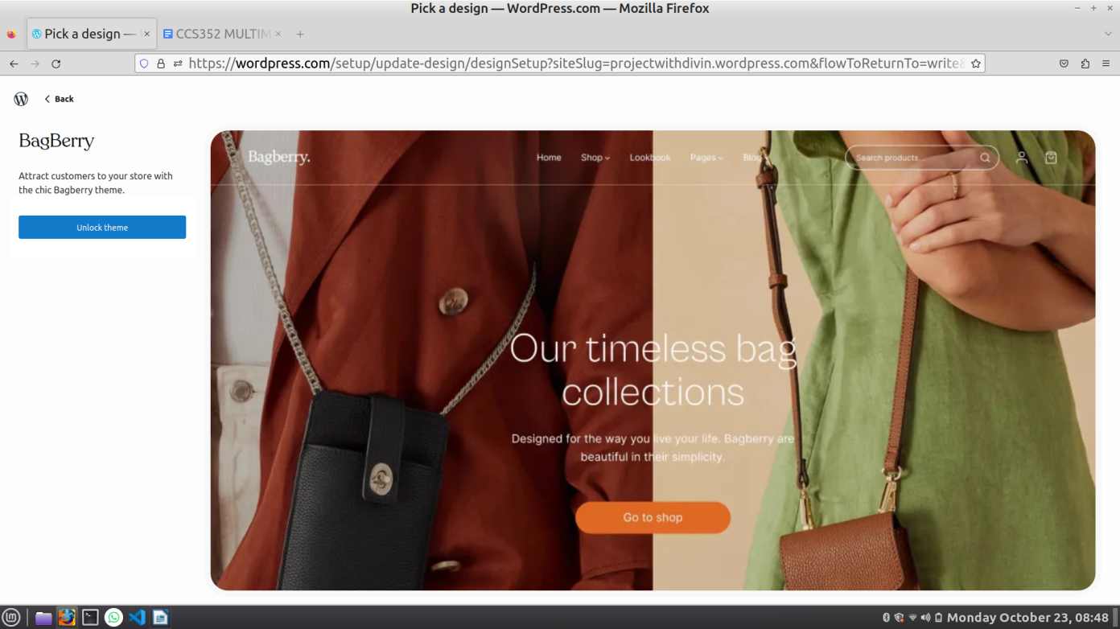

**Result:**

Thus, the expected design using word press was achieved successfully.

|  |  |
| --- | --- |
| **Ex. No 4.c** | **Working with Web and Mobile Authoring tool Word press to Design Responsive webpage for use on both web and mobile interface.** |
| **Date:** |

**Aim:**

To design responsive webpage for use on both web and mobile interface using Wordpress.

**Working with Wordpress Online:**

1. Go to the browser and paste the link <https://wordpress.com/>
2. Click on the get started and create a account.
3. Choose free plan as shown in the picture.







1. Click on the third option choose a design as shown in the image.



1. Choose any of the design as shown in the image and start editing.



1. Once done, your site looks similar to the image as shown.



1. In the above image you can see in the upper side as Desktop view, Tablet view and Mobile View.
2. Thus, We Created a Responsive website.

**Result:**

Thus, the expected design using word press was achieved successfully.

|  |  |
| --- | --- |
| **Ex. No 5.a** | **Perform a simple 2D animation with sprites.** |
| **Date:** |

**Aim:**

To perform a simple 2D animation with sprites in Blender.

**Procedure:**

1. Go to the browser and paste the link <https://www.blender.org/download/>
2. **Open Blender**: Launch Blender and make sure you are in the 2D Animation workspace.
3. **Import Sprites**: You'll need your 2D sprites in a format that Blender can use (such as PNG). To import them, go to File > Import > Images as Planes. Select the images you want to use as sprites.

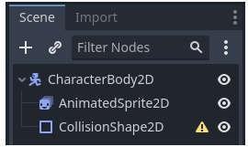

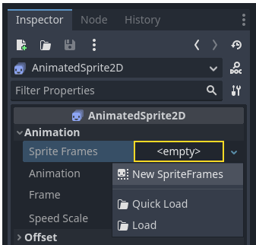

1. Click on the new Sprite Frames resource and you'll see a new panel appear at the bottom of the editor window

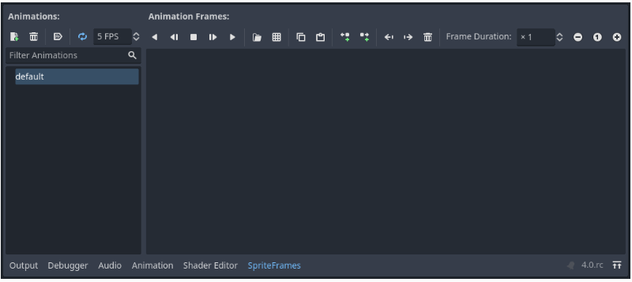

1. File System dock on the left side, drag the 8 individual images into the center part of the Sprite Frames panel. On the left side, change the name of the animation from "default" to "run".

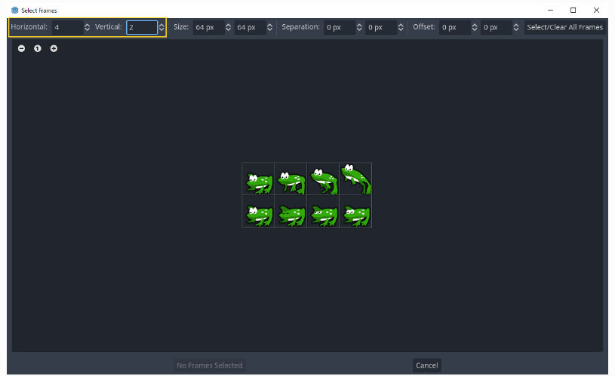

1. Next, select the frames from the sprite sheet that you want to include in your animation. We will select the top four, then click "Add 4 frames" to create the animation.

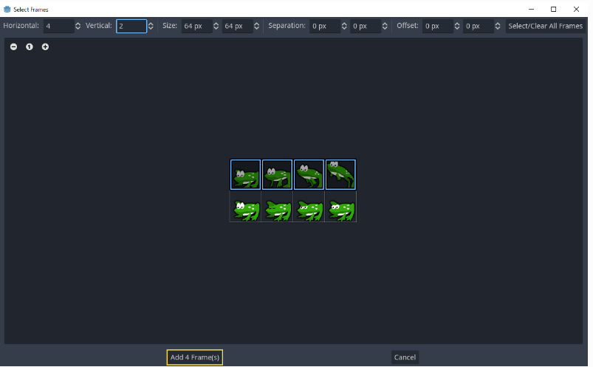

1. You will now see your animation under the list of animations in the bottom panel. Double click on default to change the name of the animation to jump.

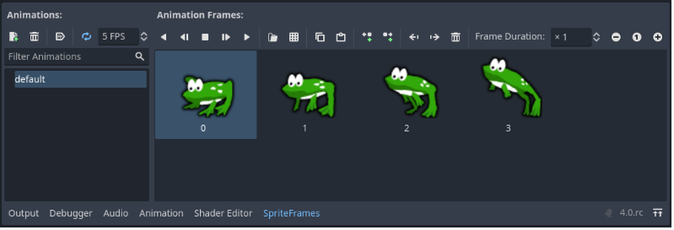

1. Finally, check the play button on the Sprite Frames editor to see your frog jump.

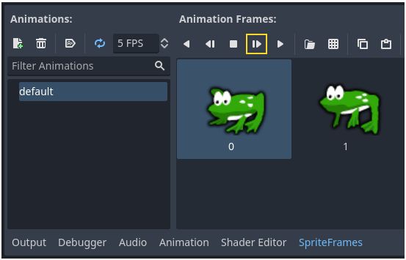

**Result:**

Thus, the expected design using a simple 3D animation with key frames kinematics in krita was created successfully.

|  |  |
| --- | --- |
| **Ex. No 5.b** | **Perform simple 3D animation with key frames, kinematics** |
| **Date:** |

**Aim:**

To perform simple 3D animation with key frames, kinematics in Blender.

**Procedure:**

1. Go to the browser and paste the link <https://krita.org/en/download/krita-desktop/>
2. Open Krita and Create a New DocumentYou can specify the canvas size and resolution as per your preference.
3. Go to Settings > Switch Workspace > Animation. This will switch Krita to the animation workspace.

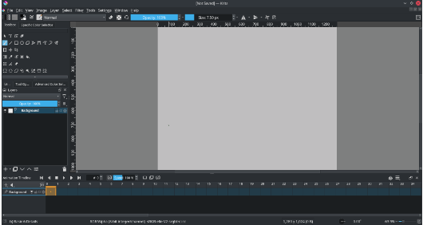

1. In the timeline panel at the bottom, click the "+" button to add a new animation layer.

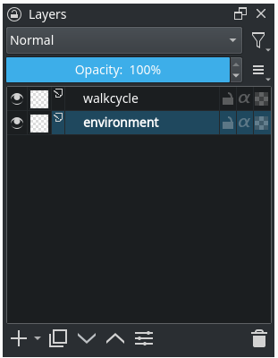

1. On the first frame of the animation layer, draw the initial state of your object or character.

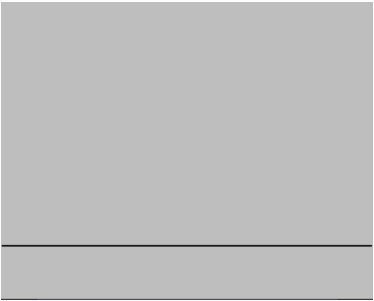

1. Use the "Transform Mask" tool to manipulate the object.

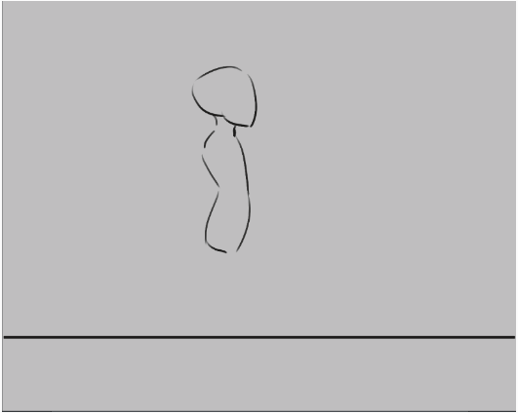

1. To draw the two extremes of the walk cycle.

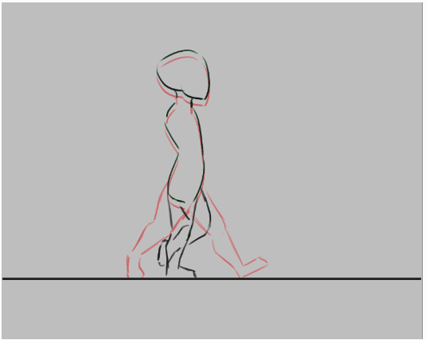

1. Click the "Record Animation" button (the red dot in the timeline panel) to start recording your key frames.
2. Move, rotate, or scale the object as desired, and Krita will automatically create key frames for you.
3. Use the timeline to adjust the timing of your animation. You can drag the keyframes to change their position in time.
4. Select all frames in the timeline docker by dragging-selecting them.

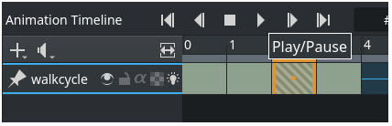

1. Use the play button in the timeline panel to preview your animation

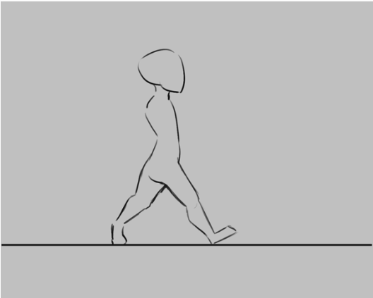

1. Once you're satisfied with your animation, you can export it as a GIF or video file by going to File > Render Animation.

**Result:**

Thus, the expected design using a simple 3D animation with key frames kinematics in krita was created successfully.

|  |  |
| --- | --- |
| **Ex. No 6.a** | **Working with E-Learning authoring tool EdApp to Demonstrate screen recording and further editing for e-learning content.** |
| **Date:** |

**Aim:**

To demonstrate screen recording and further editing for e-learning content using EdApp.

**Procedure:**

1. Go to the browser and paste the link <https://www.edapp.com/>
2. Click on the get started for free as shown below

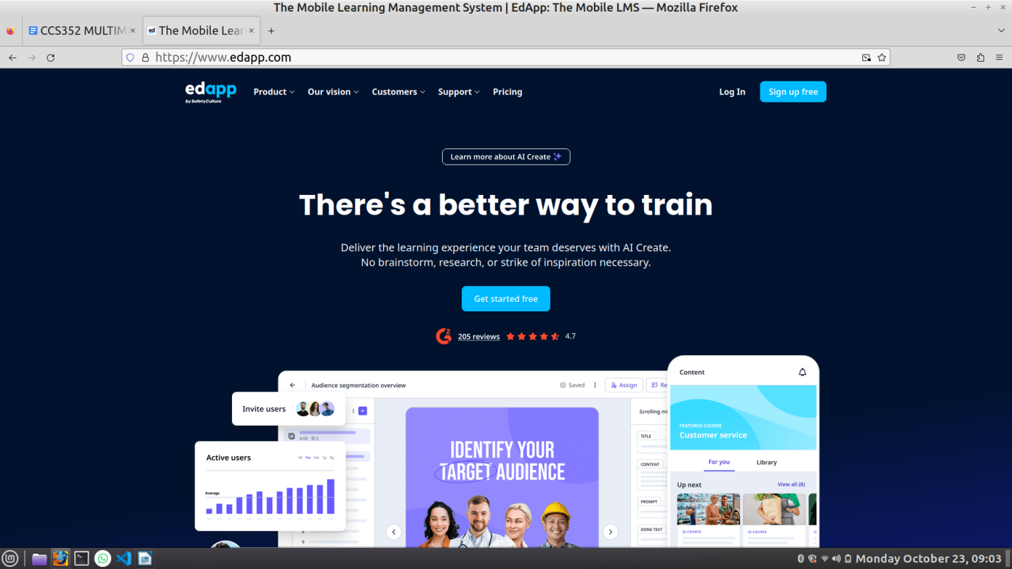

1. Enter the required details and create a free account in the platform as shown in the image.

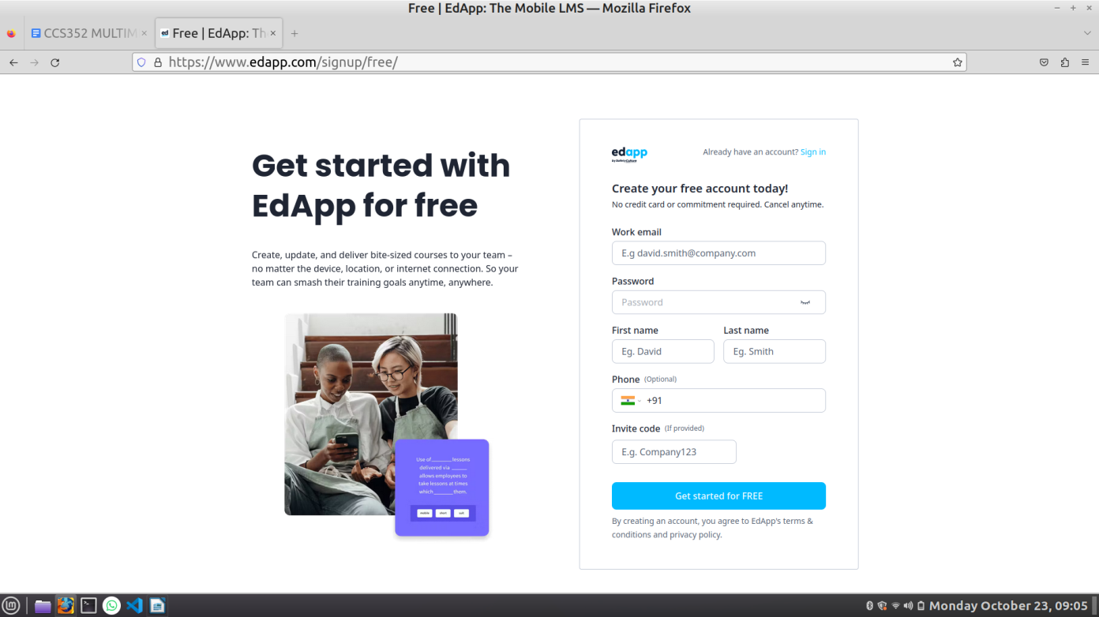

1. Give sample company details as your own as shown in the image

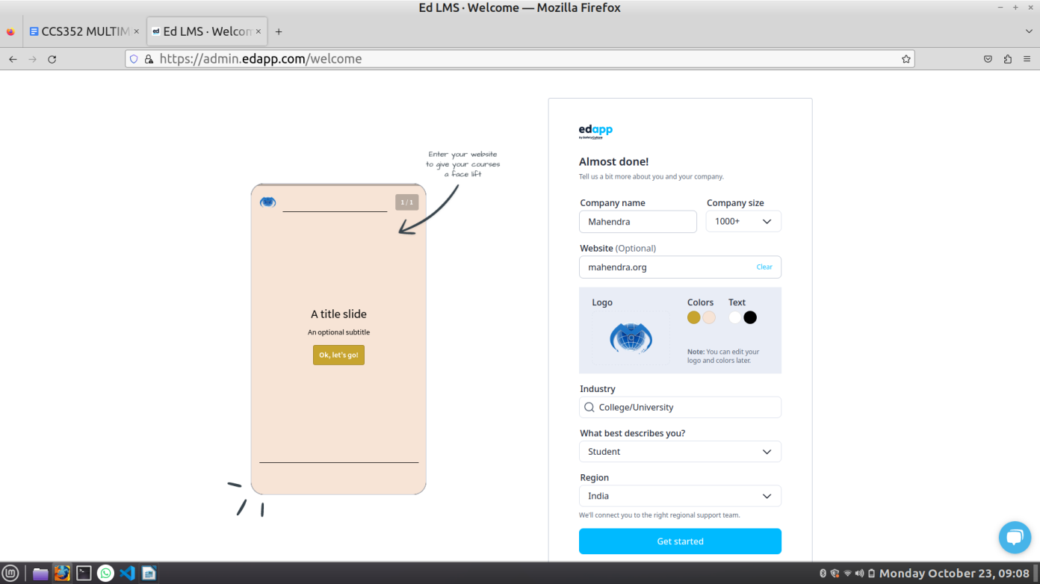

1. Click on the get started button.
2. Click on the Create course with blank as shown in the image.

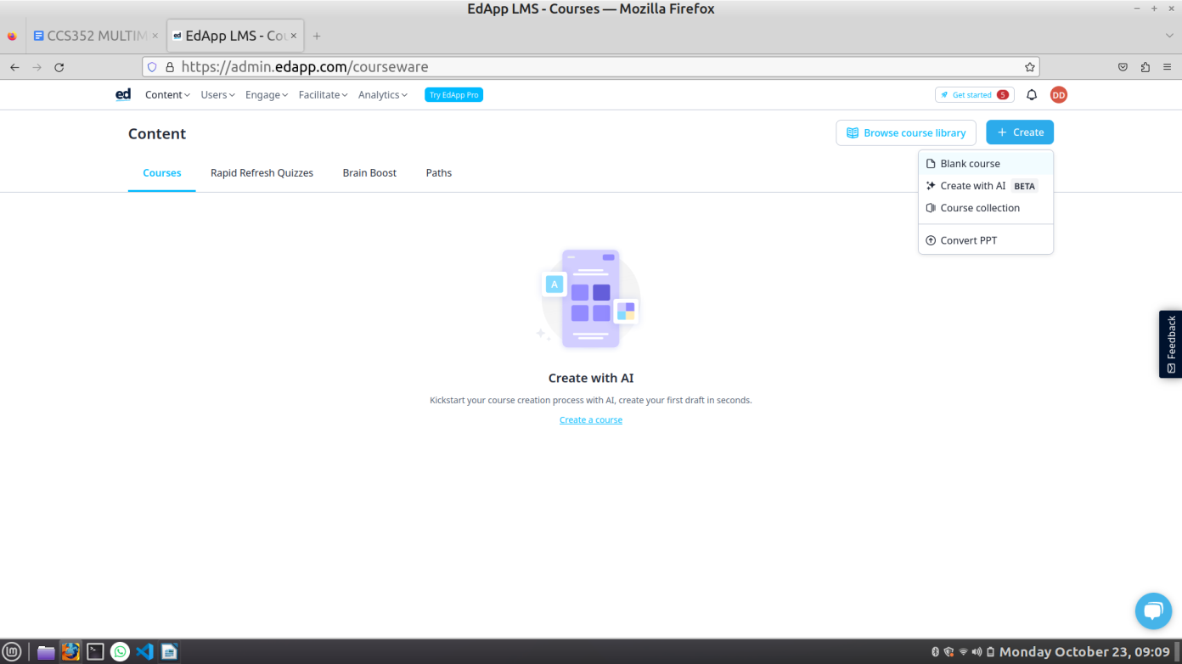

1. Click on the plus icon on the left navigation bar

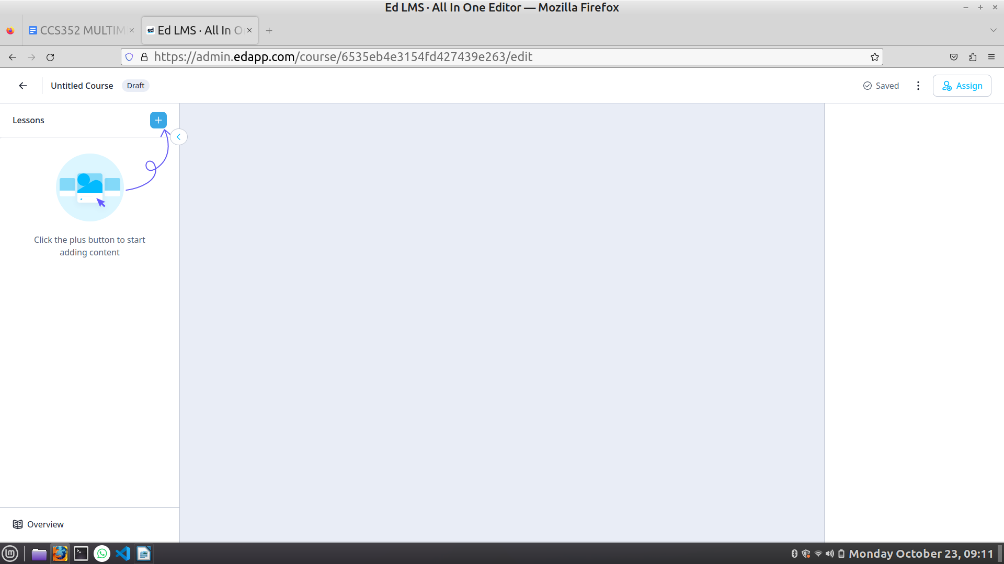

1. In the right of the navigation you can add the audio or any other media files and then you can edit it as per your needs as shown.

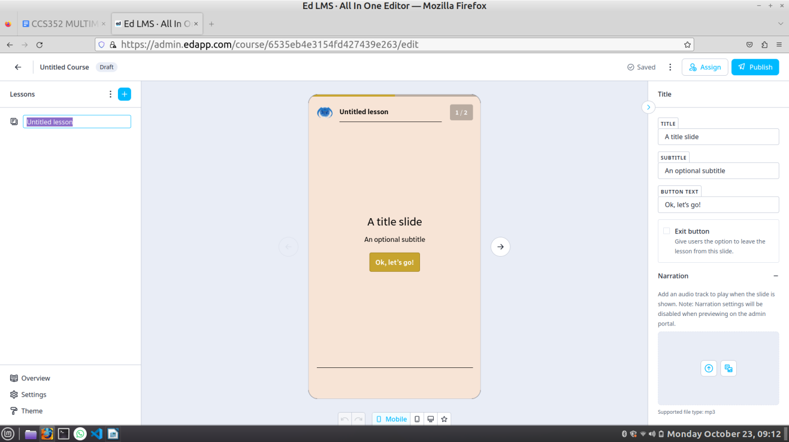

**Result:**

Thus, we executed screen recording and we also know how to edit e-learning content in the EdApp platform.